Practice Assignment 2
Logistic Regression
  - Discussion on Friday, May 8th at 3 PM
- This problem will use the USTempLocation.csv file on GitHub. In this data set, the average low temperature in January is given along with latitude and longitude of various cities in the United States. Additionally, the cities region in the US (Northeast, Midwest, South, or West) and whether the city is over 1 million in population or not are given.
  - Read in the dataset and load the math3150package library. Then change the CitySize variable to be a factor with the first level "Under1M" and the second level "Over1M". This can be done using
city_data <- mutate(
city_data,
CitySize = factor(CitySize, levels = c("Under1M", "Over1M"))
)
where city_data is the name of the data frame.
Done!
  - Fit a logistic regression model predicting the size of a city using JanTemp and Region. Don’t forget to put family = binomial(). Write down or type the logistic regression model here.
The model can be written either of these ways:
$$logit\left(\hat{π}\left(x\right)\right)=-4.46+0.1096x_{1}+0.6211x_{2}-2.443x_{3}-0.4746x_{4}$$
or
$$\hat{π}\left(x\right)=\frac{exp(-4.46+0.1096x_{1}+0.6211x_{2}-2.443x_{3}-0.4746x_{4})}{1+exp(-4.46+0.1096x_{1}+0.6211x_{2}-2.443x_{3}-0.4746x_{4})}$$
where $x_{1}$ = average January low temperature,
$x_{2}$ = 1 if the city is from the Northeast and 0 otherwise,
$x_{3}$ = 1 if the city is from the South and 0 otherwise,
$x_{4}$ = 1 if the city is from the West and 0 otherwise.
  - Are any of the variables significant in this model? If so, which ones and how do you know?
Yes, January temperature is significant since it has a small p-value of 0.02742.
  - Which region is being treated as the baseline here? Explain how you know.
The region “Midwest” is being treated as the baseline since it is not given an indicator variable in our model. R, by default, treats the first category alphabetically as the baseline unless that is changed.
  - Interpret the slope of JanTemp in the model.
The slope of JanTemp is 0.1096. This indicates that as the average January low temperature in a city increases by 1 degree Fahrenheit, the predicted odds that a city has over 1 million people changes by a factor of $e^{0.1096}=1.1158$, holding region constant. Or we can say that as the average January low temperature in a city increases by 1 degree Fahrenheit, the predicted odds that a city has over 1 million people increases by about 11.58%, holding region constant.
  - Interpret the slope of RegionSouth in the model.
The slope of RegionSouth is -2.443. This indicates that as the region is changed from Midwest to South, the predicted odds that a city has over 1 million people changes by a factor of $e^{-2.443}=0.0869$, holding average January low temperature constant. Or we can say that as the region is changed from Midwest to South, the predicted odds that a city has over 1 million people decreases by 91.31%, holding average January low temperature constant.
  - Find the predicted probability of the city having a population over 1 million if it is in the Northeast region with a January low temperature of 20 degrees. Putting
type = "response" in the predict() function will be helpful here.
The predicted probability is 0.1617.
  - Produce a table with all the actual and all the predicted values from this model using 0.50 as the probability cutoff for predicted the city has over 1 million people. What percent of cities were classified correctly? Does it seem like the model is doing a good job at predicting city size?
prediction
truth 0 1
Under1M 48 1
Over1M 6 1
The percent of correctly classified cities is $\frac{48+1}{48+6+1+1}⋅100\%=\frac{49}{56}⋅100\%=87.5\%$. While that is a good percentage, it is misleading. There are far fewer cities with a population under 1 million in the dataset than there are over 1 million. So while the overall accuracy is pretty good here, our model only predicted 2 cities as having a population over 1 million and only one of those was correct. There are other measures we will consider later of how to evaluate a logistic regression model’s performance.
  - Use the logistic_plots() function in math3150package to make plots for the model. Based on these plots, comment on the diagnostics for this model.
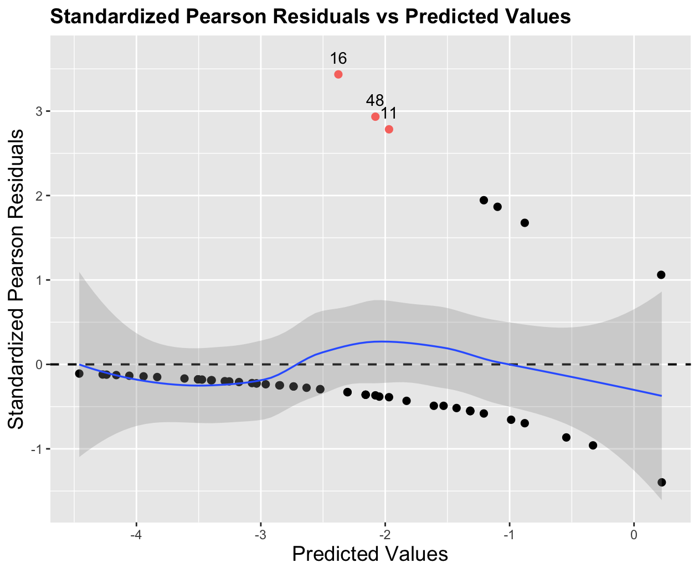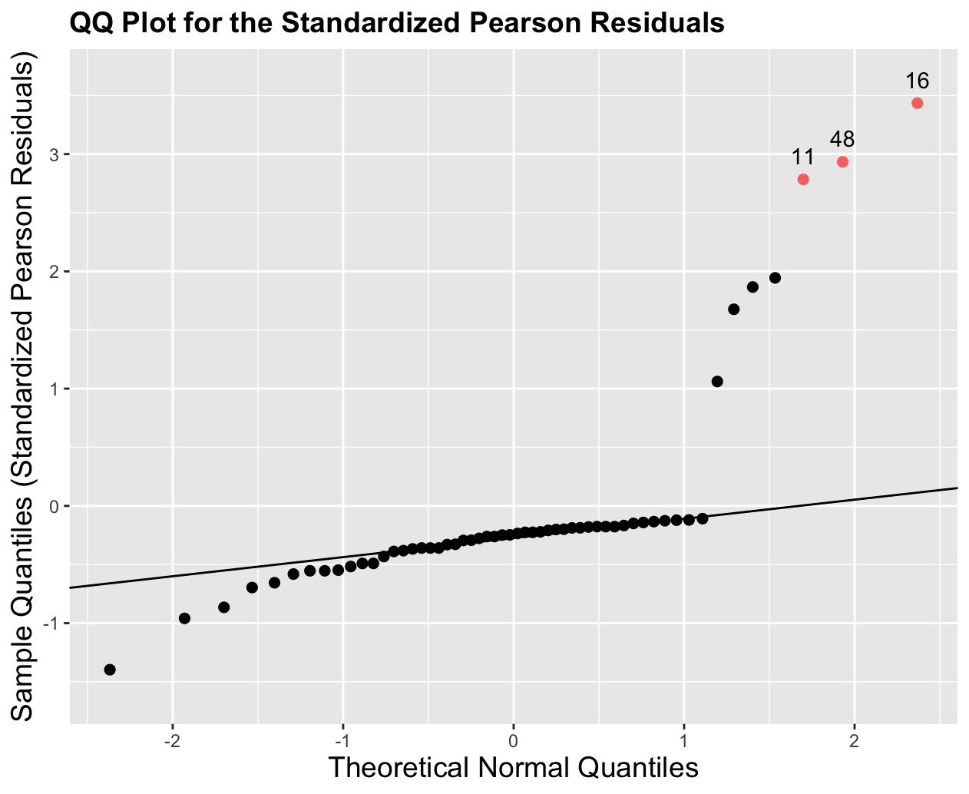
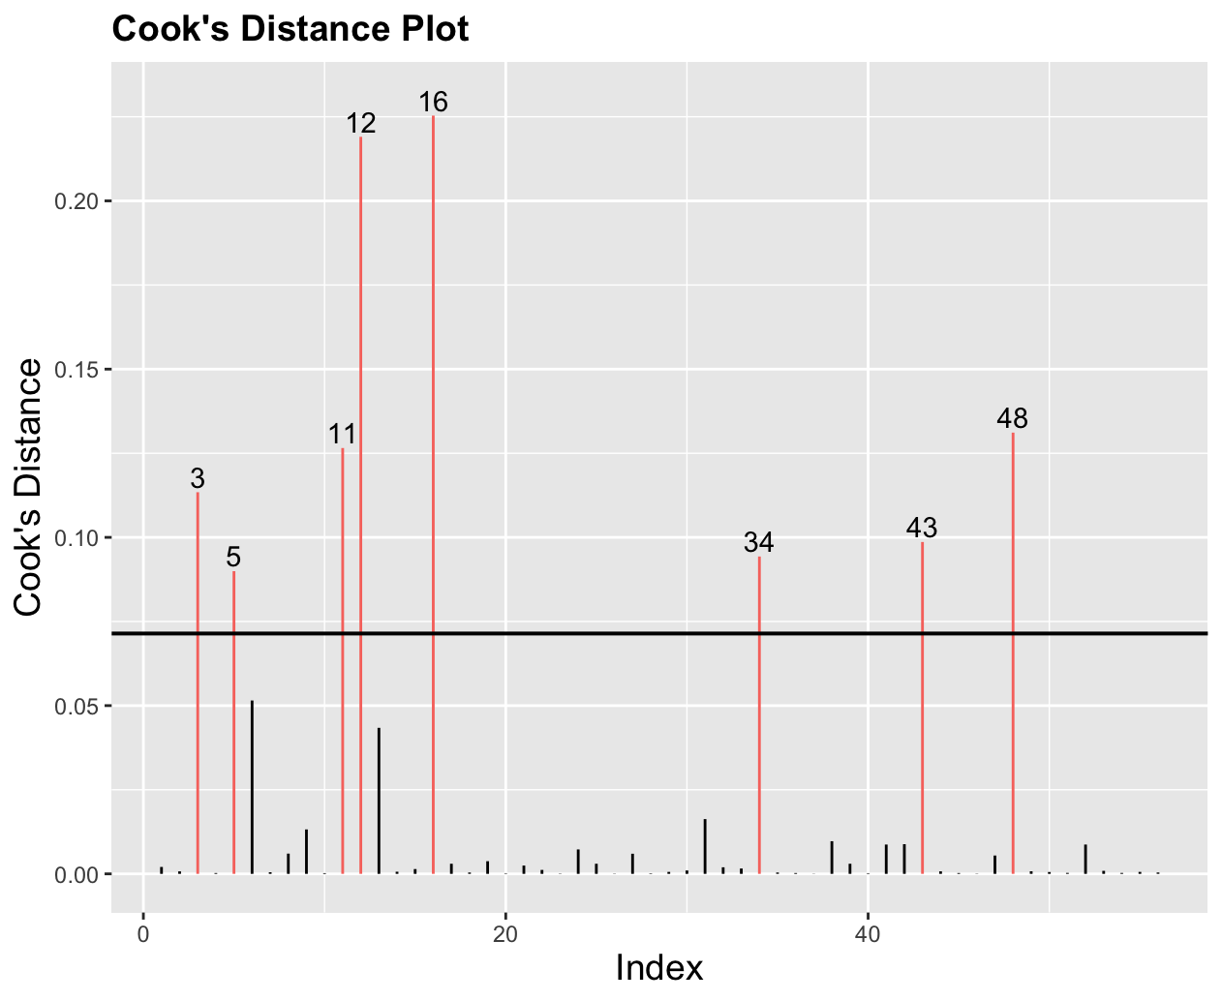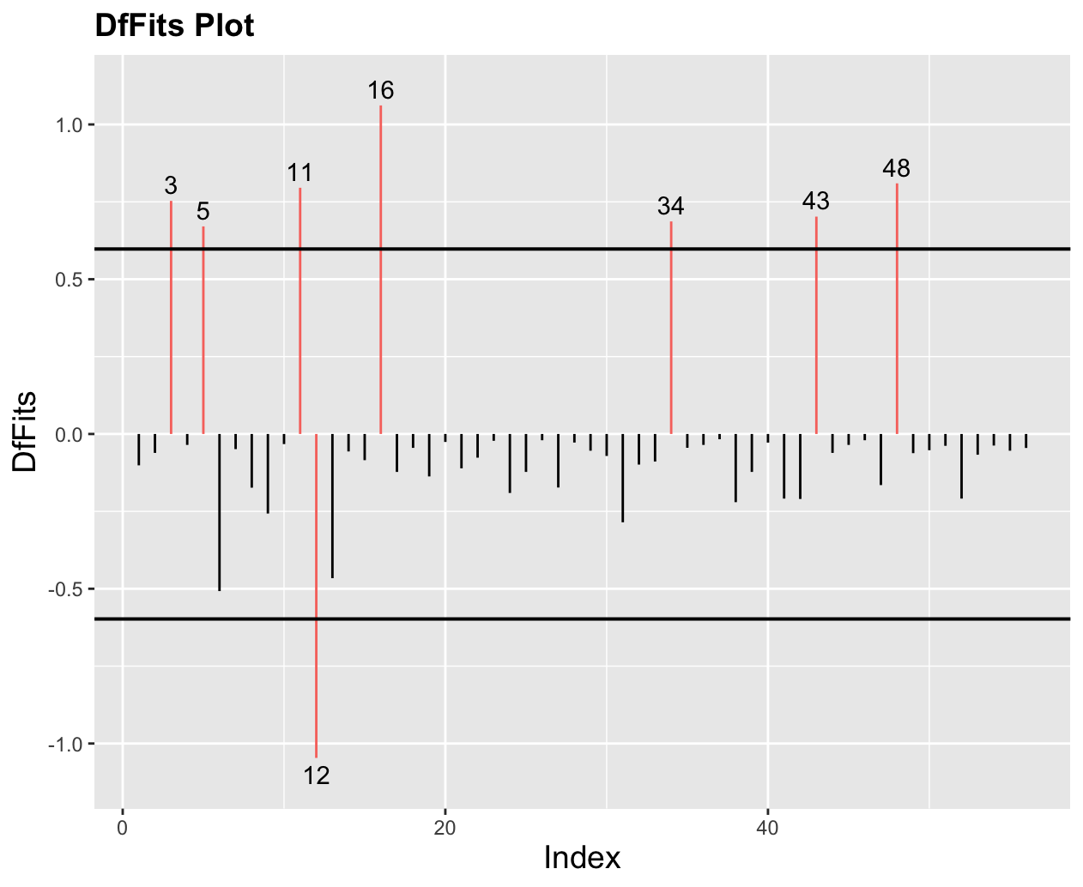
The DfBetas plots are omitted here. Points 16, 48, and 11 show up as unusual here. Those correspond to Chicago, IL, Houston, TX, and Jacksonville, FL. Each of those happens to be a city with a population over 1 million.

The residual plot doesn’t look concerning. The QQ plot does not look good, but that is less important for logistic regression.
- Three airlines serve a small town in Ohio. Airline A has 45% of all scheduled flights, airline B has 38% and airline C has the remaining 17%. Their on-time rates are 82%, 73%, and 51%, respectively. A flight just left on time. What is the probability that it was a flight of airline A?

We want
$P\left(Airline A \right| On time)=\frac{P(Airline A and On time)}{P(On time)}$
$=\frac{P(On time|Airline A)⋅P(Airline A)}{P(On time|Airline A)⋅P(Airline A) + P(On time|Airline B)⋅P(Airline B) + P(On time|Airline C)⋅P(Airline C)}$
$=\frac{0.82⋅0.45}{0.82⋅0.45+0.73⋅0.38+0.51⋅0.17}=\frac{0.369}{0.7331}=0.503342$.

Or use a tree diagram:
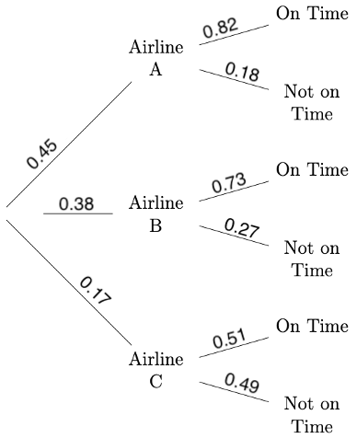
$P\left(Airline A \right| On time)=\frac{0.45⋅0.82}{0.45⋅0.82+0.38⋅0.73+0.17⋅0.51}=0.503342$.

